DOOR BUZZER USING ULTRASONIC SENSOR

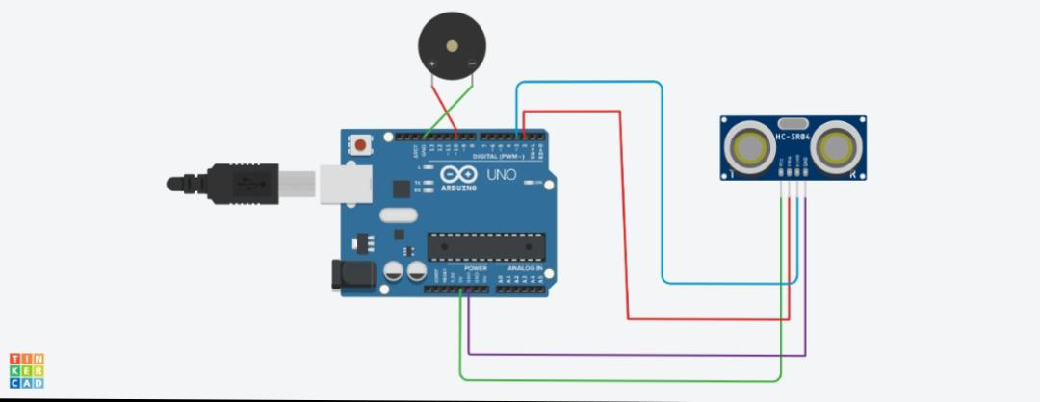

COMPONENTS :

* ARDUINO UNO R3

* ULTRASONIC DISTANCE SENSOR
* PIEZO

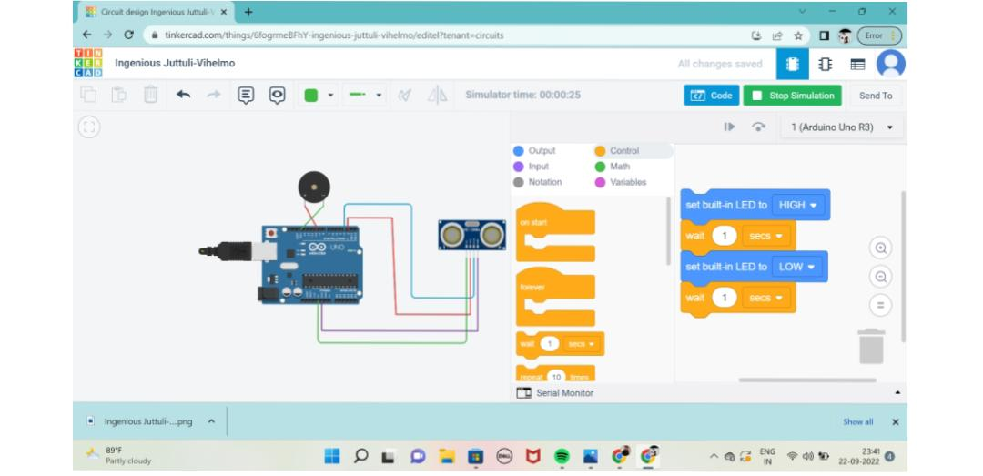

**CODING :**

// C++ code

//

Void setup()

{

pinMode(LED_BUILTIN, OUTPUT);

}

Void loop()

{

digitalWrite(LED_BUILTIN, HIGH);

delay(1000); // Wait for 1000 millisecond(s)

digitalWrite(LED_BUILTIN, LOW);

delay(1000); // Wait for 1000 millisecond(s)

}